



MICROSOFT ARCHITECTURE BEST PRACTICE FOR AI BUSINESS PROCESS
USECASE: AI SEARCH INDEX

Document Title | Microsoft Cloud Center of Excellence Overview
Presales/Technical Head | Tushar Mehrotra/Rohit Pandey
CCoE Lead | Ravishankar N
Creation Date | 10th November 2025
Version | Description | Modified by | Date | Approved by | Date
1 | Draft architecture baseline for review | Sharmila Devi K | 30/10/2025 | Ravi Shankar | 30/10/2025
2 | Updated draft with architecture refinements and review comments | Sharmila Devi K | 04/11/2025 | Ravi Shankar | 04/11/2025
3 | Final approved architecture design | Sharmila Devi K | 10/11/2025 | Ravi Shankar | 10/11/2025
Contents

1. Executive Summary 3
2. Scope and Applicability 3
3. Business Scenario Overview 3
4. Reference Architecture Overview 4
4.1 Architecture Description 4
5. Logical Architecture Components 5
5.1 Storage Layer 5
5.2 Indexing Layer 6
5.3 Query and Consumption Layer 6
6. Architectural Best Practices 6
6.1 Azure Well-Architected Framework Alignment 6
6.2 Governance & Operational Controls 7
6.3 Security and Data Protection 7
7. Cloud Center of Excellence Enablement Model 7
8. Reusability and Scalability 7
9. Conclusion 8

AZURE AI SEARCH INDEX

Executive Summary
This document defines the standardized reference architecture and architectural best practices maintained by the Cloud Center of Excellence (CoE) to enable the design and delivery of document search solutions using Azure AI Search, indexing both file content and associated metadata stored in Azure Blob Storage.
The objective of this architecture is to:
- Provide a repeatable and governed search design pattern
- Enable reseller-led and through-channel search solutions
- Ensure alignment with Microsoft Azure Architecture Center and Well-Architected Framework
- Serve as audit-ready evidence for Cloud Center of Excellence capabilities under the Microsoft Frontier Distributor designation

Scope and Applicability
This reference architecture applies to:
- CSP distributors and reseller ecosystems
- Knowledge management and document discovery workloads
- Compliance, legal, contract, and content search solutions
- SMB, Mid-Market, and Enterprise environments
- Multi-region and global CSP authorizations
The architecture is designed for consistent application across regions, supporting the Frontier Distributor requirement for globally aligned Cloud Centers of Excellence.

Business Scenario Overview
Organizations typically store large volumes of unstructured documents in Azure Blob Storage, while maintaining additional business or contextual metadata in separate systems.
Business users require the ability to:
- Search document content (full-text search)
- Filter and refine results using metadata attributes
- Access search results securely and efficiently
- Integrate search into reseller or customer-facing applications
Azure AI Search enables a single unified search index built from multiple data sources, allowing documents to be searched using both content and metadata, as defined in Microsoft’s reference architecture.

Reference Architecture Overview

4.1 Architecture Description
The solution follows a multi-indexer, single-index pattern:
- Azure Blob Storage stores document files and intrinsic blob metadata
- Azure Table Storage (or equivalent) stores extended document metadata
- Azure AI Search uses multiple indexers to ingest content and metadata into one search index
- Applications query the unified index for search results
This architecture pattern is recommended by Microsoft for scalable and maintainable document discovery solutions.
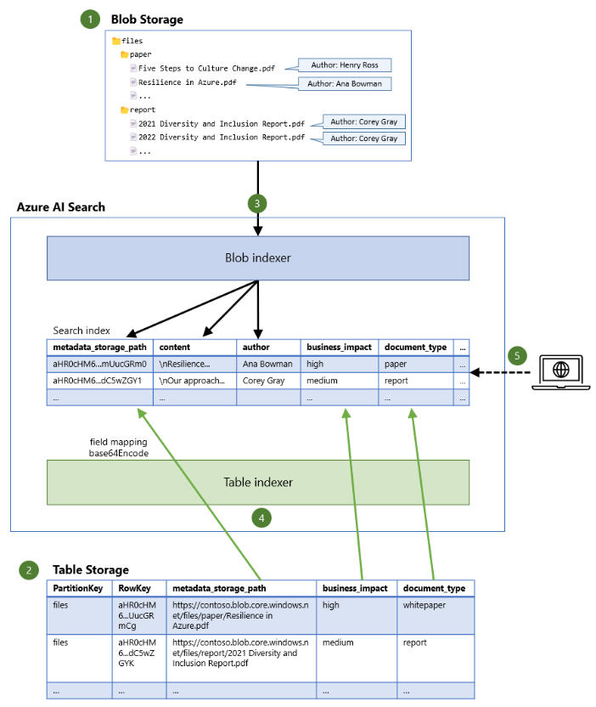

Logical Architecture Components

5.1 Storage Layer
Azure Blob Storage
- Primary store for documents (PDF, Office files, CSV, HTML, etc.)
- Holds intrinsic blob metadata (file name, path, modified date)
Azure Table Storage
- Stores structured or extended metadata (classification, ownership, retention tags)
- Scales independently of blob storage

5.2 Indexing Layer
Azure AI Search
- Managed search service
- Hosts the unified search index
- Supports full-text search, filtering, and faceting
Blob Indexer
- Extracts file content from blobs
- Extracts intrinsic blob metadata automatically
Table Indexer
- Reads structured metadata from Table Storage
- Maps metadata records to existing documents in the search index

5.3 Query and Consumption Layer
- Line-of-business applications
- Reseller or customer portals
- Knowledge repositories
- REST or SDK-based integrations
Applications submit search queries and receive results based on both content relevance and metadata filters.

Architectural Best Practices

6.1 Azure Well-Architected Framework Alignment
Pillar | Implementation Approach
Reliability | Managed AI Search service with built-in resiliency
Security | Azure RBAC, managed identities, encrypted storage
Performance | Proper partitioning and replica configuration
Cost Optimization | Right-sized search tiers and index strategies
Operational Excellence | Automated indexing and monitoring

6.2 Governance & Operational Controls
- Standardized index naming and schema conventions
- Change detection using blob timestamps
- Centralized monitoring using Azure Monitor
- Environment separation (dev, test, production)
- Controlled metadata schema evolution
These practices ensure repeatable, auditable deployments across the reseller ecosystem.

6.3 Security and Data Protection
- Role-based access control to Blob Storage and Search service
- Secure access to search endpoints using Entra ID or API keys
- Separation of sensitive metadata from document content
- Support for compliance and regulated search scenarios

Cloud Center of Excellence Enablement Model
The Cloud Center of Excellence:
- Defines and governs approved reference architectures
- Maintains reusable design patterns and templates
- Provides architectural guidance and best practices to resellers
- Ensures consistency with Microsoft-recommended architectures
- Maintains a centralized knowledge repository accessible across regions
This operating model fulfills the Cloud Center of Excellence requirements defined in the Frontier Distributor checklist.

Reusability and Scalability
This reference architecture is:
- Reusable across industries and workloads
- Scalable from small content repositories to enterprise-scale datasets
- Suitable for regional and global CSP models
- Compatible with through-channel and co-delivery engagements

Conclusion
This Cloud Center of Excellence reference architecture provides a Microsoft-aligned, audit-ready, and repeatable design for implementing Azure AI Search over blob content and metadata. It enables distributors to consistently support reseller and customer search solutions while maintaining governance, security, and architectural excellence across all regions.

